***REQUIREMENTS***

GUIDELINES

The classic three-tier architecture should be employed:

1)Presentation Layer: GUI in Java (NetBeans IDE)

2)Application Layer:Java

3)Storage (persistence layer): Relational database (e.g.MS Access)

***JFRAME (TABS WE NEED)***

USER(new user or existing)

ADD USER (name,address,email ….)

BUY(team,number)

RENT(team,number,return date …)

RETURN RENTED (rent id)

RETURN PURCHASED(purchase ID)

REMOVE USER (User ID)

***TABLE LINKAGE***

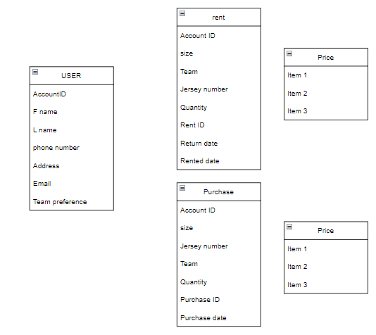

Low fidelity prototype:

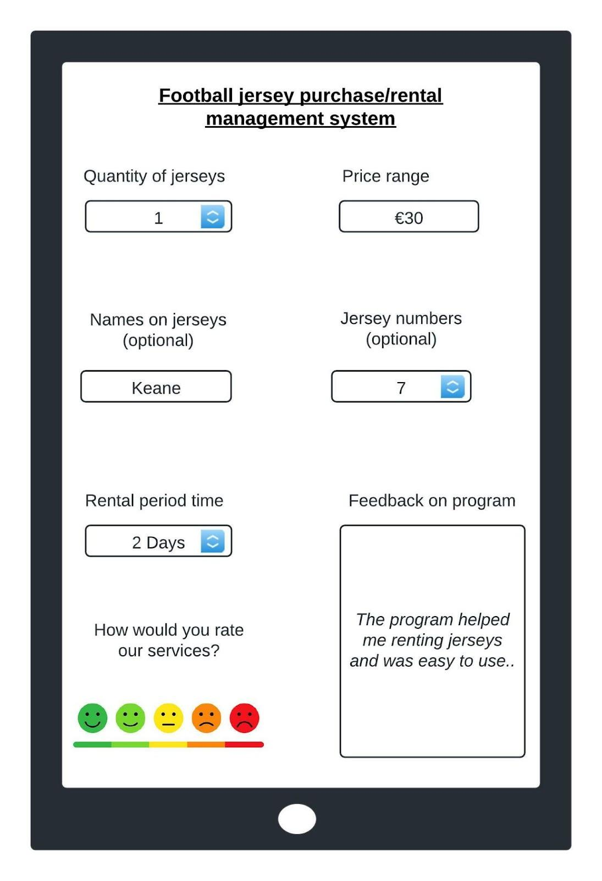

The blue arrows will allow you to increment or decrement the number selected as opposed to getting the user to enter a number, this will also eliminate input error.

A button may need to be added to ‘order’ the jerseys; this could then lead to an order confirmation screen in which the rating services will be shown instead of being on the home page.

The users ratings and feedback could be written to an SQL database in order to store the data and log any requests made or number of orders or even amount of profit made from sales etc.

Price range could also be changed to a slider:

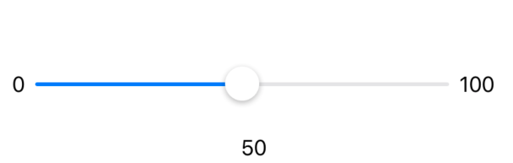

**Requirements (DESIGN):**

~~Allow stock /inventory control to be maintained~~

~~Allow management to print lists of users and lists of stock~~

~~Allow the addition and removal of users~~

~~Allow management to check overdue accounts~~

~~Allow users to rent and purchase items/service~~

~~Allow users to return rented/purchased items~~

**Requirements (CODE):**

Allow stock /inventory control to be maintained

Allow management to print lists of users and lists of stock

Allow the addition and removal of users

Allow management to check overdue accounts

Allow users to rent and purchase items/service

Allow users to return rented/purchased items

**Requirements (DATABASE):**

Allow stock /inventory control to be maintained

Allow management to print lists of users and lists of stock

Allow the addition and removal of users

Allow management to check overdue accounts

Allow users to rent and purchase items/service

Allow users to return rented/purchased items